Marisa Bussone, Heechan Kim, Shivani Patel, Ralston Tuason

Cogsci 131

Project #1

2. Read about the elastic band method and describe what it is about. Use figure 2, shown below, from the paper in [1]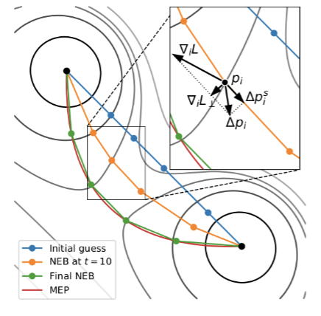

The nudged elastic band (NEB) method is used to find minimum energy paths (MEP) and saddle points. We are concerned with the NEB’s application to minima of neural networks. In this case, an MEP is a path with the lowest maximum loss i.e., energy, from one minima to another across parameter space. A saddle point is the “parameter set with the maximum loss on a path” (Draxler et. al, 2). The NEB takes in a known initial minima and final minima. These points are connected via transition images, and these transition images are connected via springs. To find the MEP, several points between the initial and final points are guessed. Eventually, the MEP is found by optimizing the minimum energy of all of these guessed points.

In the image above, the circled point on the left represents the initial minima. The circled point on the right represents the final minima. The blue line represents the initial guess for the MEP. This guess shows a direct connection between the two minima as indicated by the straight line. To find the MEP, the NEB bends this straight line “by applying gradient forces until there are no more gradients perpendicular to the path” (Drexler et. al, 3). These forces are indicated by the arrows extending from the orange path in the zoomed-in image. The loss force ∇ᵢL is perpendicular to the path while the spring force Δpiᔆ is parallel. These forces act along the direction of the local tangent of the MEP. In this image, t represents the number of iterations (t=10). The NEB is updated and converged (green path) until the MEP is found (red path).